Event Google Maps Integration

Date | 13 July, 2010
Author | August Li
Version | 2.0
Based on | Google Map Integration

- Use Case
Display all appointments today (for an outside sales rep). The map should zoom to the map points being passed (boundaries) and if there are multiple appointments in the same building, it should handle that. The info window should include key appointment details etc.

Please read the Google Maps licensing concerns under the Limitations (last page of this document).

- Analysis
A custom address field is added to event record. If user selects a company in the event record and the address is blank, the billing address of the company will be copied into the address.
User can then modify the address if the meeting will take place elsewhere than the company address. Convention is that if the address is populated then it means it is an off-site event and
location will indicate details like room, etc..

Geo coding is done upon save of the event record and saved to custom fields in event record (geo coding is the translation of a postal address into latitude and longitude). This is because Google Map API does not recommend calling geo coding service in succession and will throw an error if you do so in less than 200ms plus there is a 15000 call limit per day. Note that an incomplete address will cause geo coding to fail, in this case, latitude and longitude will not be populated and event will not be shown in map.

Saved search is used to select events for the day and sorted by latitude and longitude in order to make determining same location easier since it will be in sequence.

Tabs are used to display multiple events in the same location. The icon for multiple events is the balloon with a dot. Icon without a dot will mean single events.

Clicking on the icon will display the Info window showing event details. Clicking on the “+” icon will maximize the info window and display the message (html) also. For multiple events, all events will be listed. Closing the info window will recenter the markers (as per initial view).

The solution is written as portlet, a user script with beforeLoad event and as a suitelet.

- Feature Roadmap
Not on road map

- Feature Dependencies
None

- Setup Information
  - Install bundle
  - Add portlet in dashboard.
  - Create new event with address. When you exit the address field, the latitude and longitude fields will be populated. You may need to enter a more accurate address (e.g. with state and/or country) if they are not populated.

- Assumptions
None

- Solution Overview

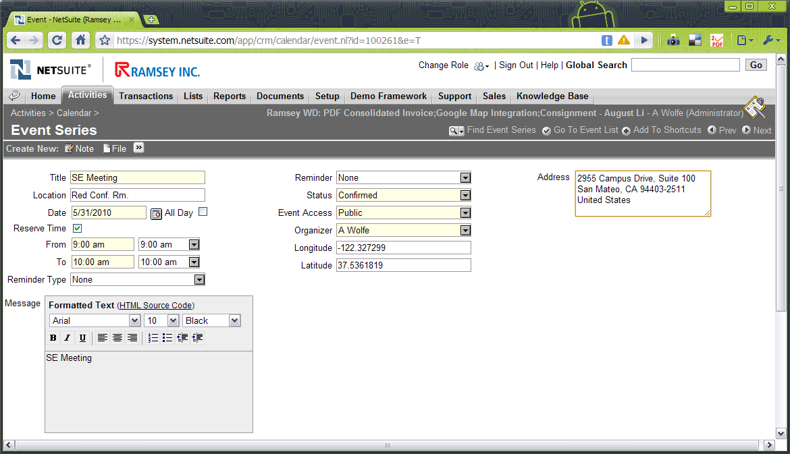
Calendar event with Address, latitude and longitude custom fields. Company is in the Related Info tab.

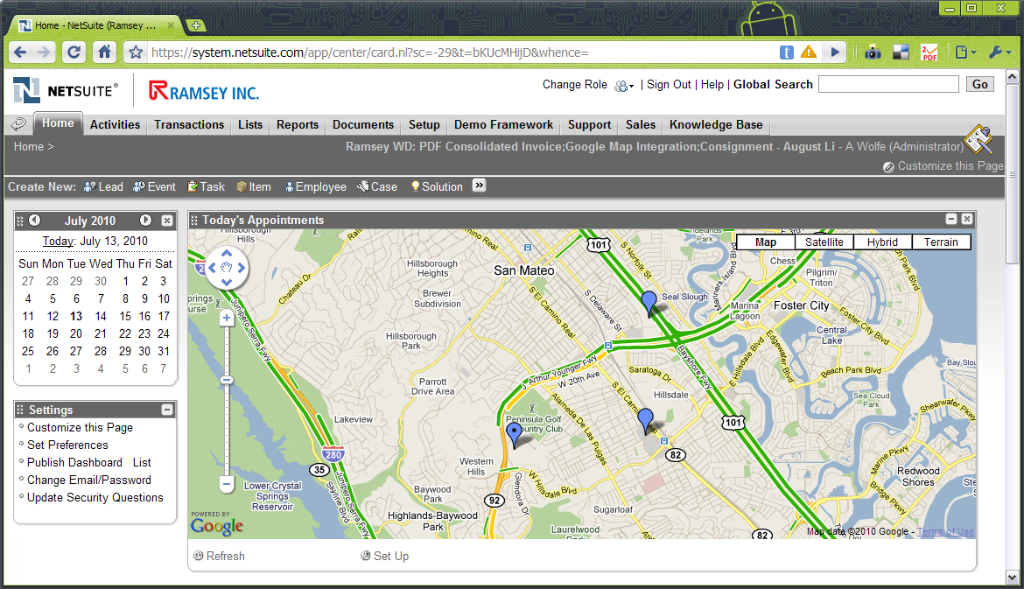
Portlet installed in dashboard will display Google Maps. Balloon with dot indicates multiple events, balloon without dot indicates single event.

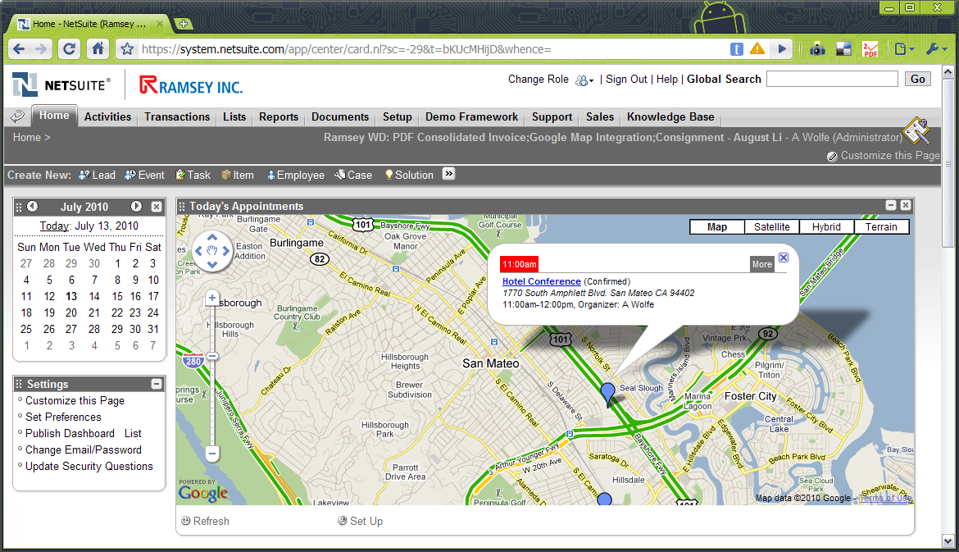
Clicking on the balloon opens the info window.

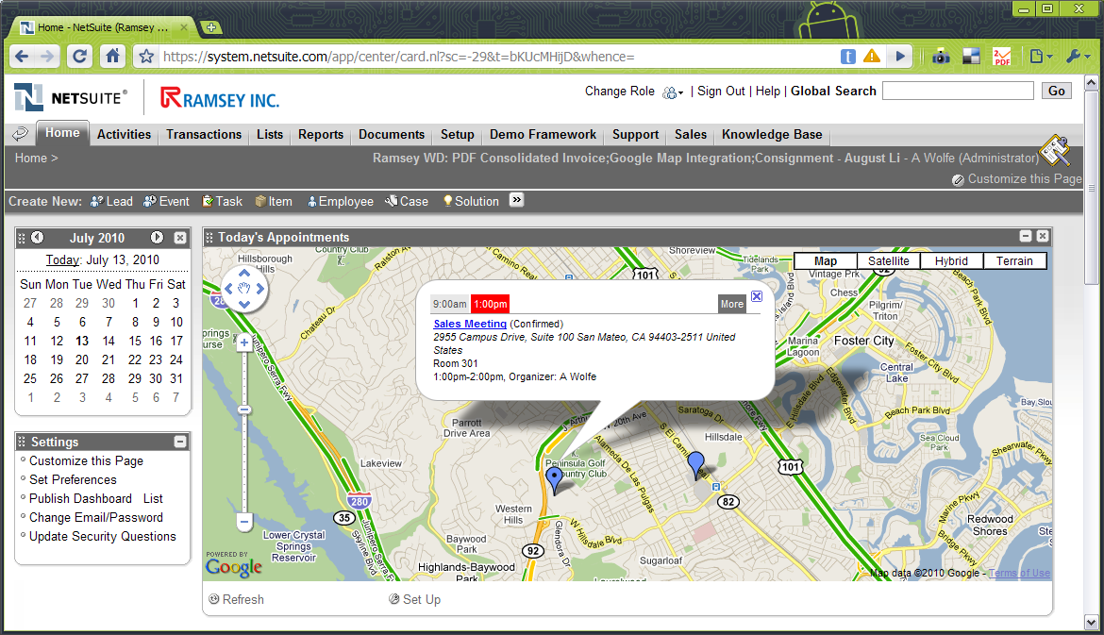
Clicking on the balloon with multiple events will open the tabbed info window.

Clicking on MORE will open the event details window.
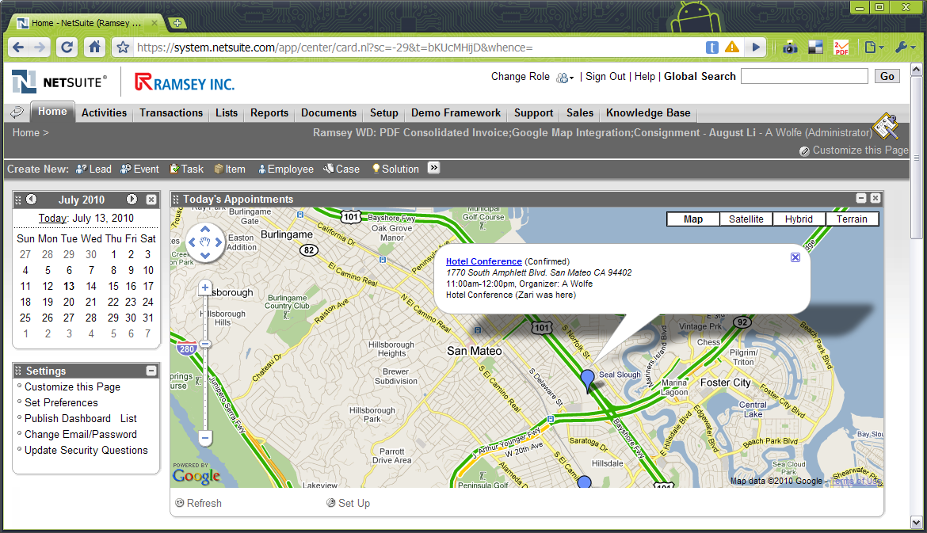
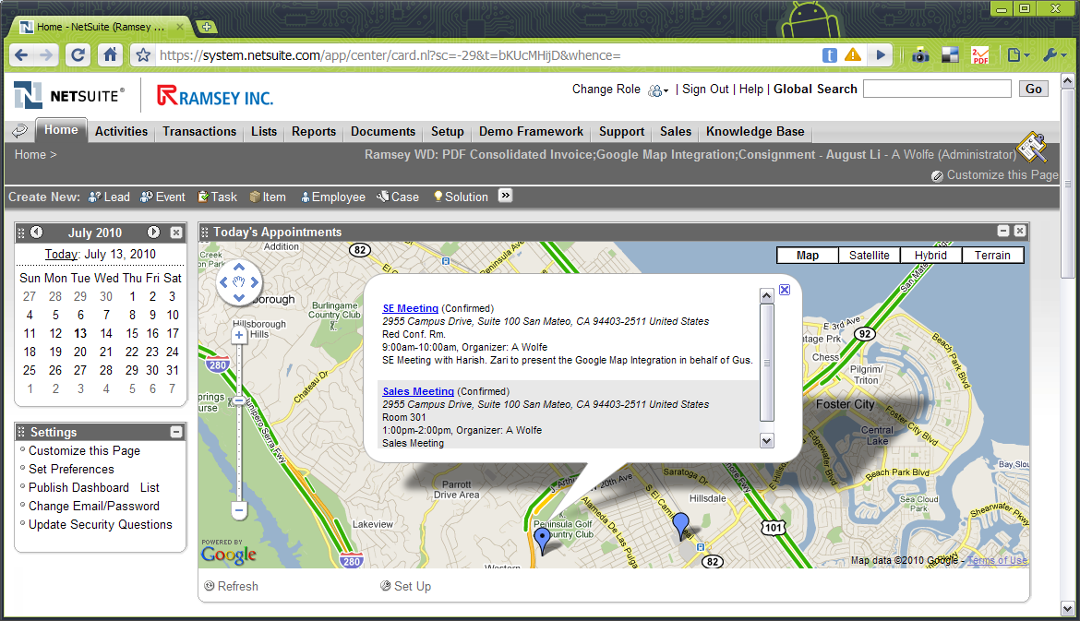

- Implementation Information
None

- Bundle Information
Install from TSTDRV625204.

- Demo Flow
- Create some event records with addresses. Verify that latitude and longitude fields are populated. It would be best to prepare valid addresses in advance.
- Go to dashboard and view portlet.
- Click on balloon to view info window.
- Click on plus icon to maximize info window.
- Close info window and the map will re-center to original position.

- PS Time Estimate
Not yet estimated.

- Limitations
  - Performance on large number of events not yet determined.
  - Google Maps is not free when implemented in accounts that require a login. A commercial Google Maps license is needed for actual implementation in production environment. Please read the Google Maps license for more details before demo to potential clients. (See http://code.google.com/apis/maps/terms.html section 9)
  - While it maybe overkill for a client to pay for Google Maps service just for their sales reps’ appointments. Please bear in mind that this demo is just to show that such integration can be done and this now opens up the possibility for more serious applications of Google Maps in their business. For example, Google Maps can calculate distances and this can be applied in determining inventory locations nearest the client’s address.

- Possible Enhancements
- Enhance handling of ambiguous addresses. (e.g. Pick from list of matched addresses)
- Show distance between events

